

**Zerto**

**Plugin Configuration Guide**

Contents

Supported Collection Types 2

Data Sources 2

Requirements 2

Network Ports 2

Zerto Configuration Checklist 2

User Configuration & Bocada Setup 2

Bocada Setup 3

Server Properties 3

Field Definitions 3

Reporting Notes 4

Technical Support 5

# Supported Collection Types

The plugin currently supports the following collection types from Zerto Virtual Manager or Zerto Cloud Appliance servers:

|  |  |  |
| --- | --- | --- |
| **Collection Type** | **Supported** | **Description** |
| Backup | ✓ | Collects transactional details about backup jobs. Example metrics include, start times, durations, bytes, files, errors etc. |
| Storage |  | Collects point-in-time inventory information. Example metrics include, total recoverable gigabytes (storage), media volume count, media volume status, etc. |
| Policy |  | Collects and stores information on policy attributes, schedules, storage units, storage groups, storage lifecycle policies and clients. |

# Data Sources

The plugin relies on the following Zerto Virtual Manager or Zerto Cloud Appliance data sources:

* ZVR RESTful APIs

# Requirements

The Bocada Data Collection Server must be able to connect to the Zerto Virtual Manager or Zerto Cloud Appliance Server on the port(s) listed in the table below.

### **Network Ports**

|  |  |  |
| --- | --- | --- |
| **Service** | **Default Port** | **Note** |
| *­­HTTPS* | 443 | REST API connection through HTTPS |

# Zerto Configuration Checklist

While detailed steps are included below, this is an overview of the steps to configure Zerto collections on your Bocada Data Collection Server:

* Credentials for users with the required permissions have been obtained

### User Configuration & Bocada Setup

Bocada collects all data for which the supplied user credentials have access. Users must be configured in App User data access.

# Bocada Setup

### Server Properties

Backup Server Properties determine how the plugin will interface with the Zerto Virtual Manager or Zerto Cloud Appliance server and are managed through the Backup Servers view.

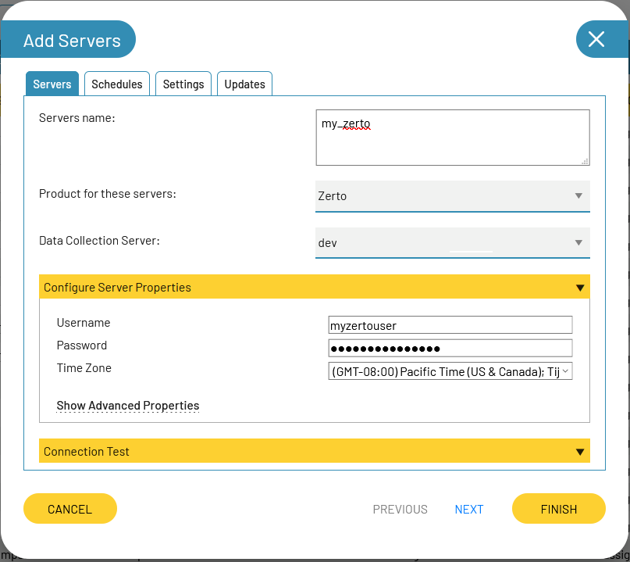

### Field Definitions

#### Username & Password

Enter the name and password for Zerto Virtual Manager or Zerto Cloud Appliance App user.

#### Time Zone

Select the time zone where Zerto Virtual Manager or Zerto Cloud Appliance server resides. This setting defines how job times will be shifted when reporting across different time zones.

# Reporting Notes

See the Zerto Status report in addition to other standard Bocada reports that include Zerto:

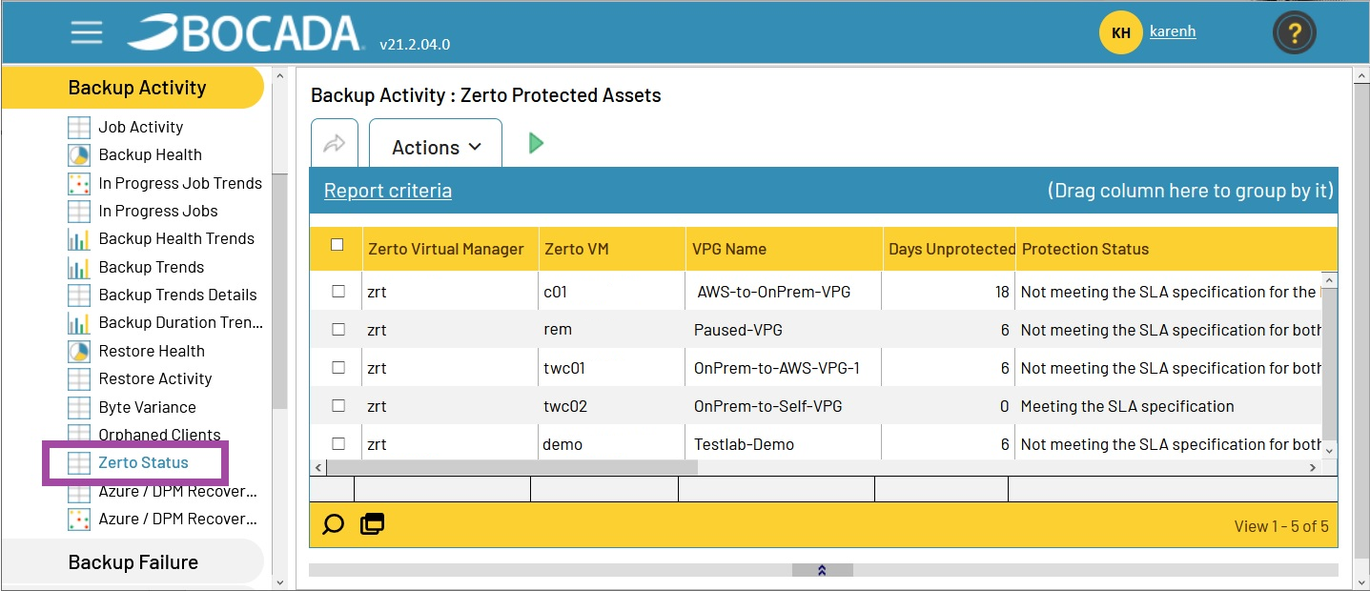

# Technical Support

For technical support or a copy of our standard support agreement, please contact us.

**E-mail:** [support@bocada.com](mailto:support@bocada.com)

**Support Portal:** http: <https://bocada-support.force.com/s/>

**Phone:** +1-425-898-2400

**Copyright © 2021 Bocada LLC.** All Rights Reserved. Bocada and BackupReport are registered trademarks of Bocada LLC. Vision, Prism, vpConnect, and the Bocada logo are trademarks of Bocada LLC. Other product names mentioned herein may be trademarks or registered trademarks of their respective companies.

Protected by U.S patents 6,640,217; 6,708,188; 6,745,210; 7,457,833; 7,469,269; 7,496,614; 8,407,227

The material in this manual is for information only and is subject to change without notice. While efforts have been made to ensure accuracy, Bocada LLC assumes no liability resulting from errors or omissions in this document, or from the use of information contained herein.

Bocada LLC reserves the right to make changes in the product design and documentation without reservation and without notification to its users. 2021-03-16